1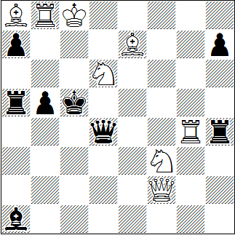
#2 8+8
2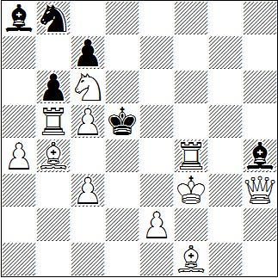
#2 11+6
3
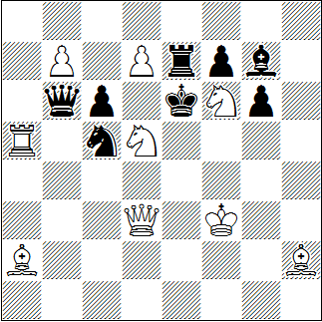
#2 9+8

Marjan Kovacevic, Original
1. | Da2! | (5)
1. | ... | dr. | 2. | Se4 #
1. | ... | Dh8+ | 2. | Se8 #
1. | ... | Dxg4+ | 2. | Sf5 #
1. | ... | Dxd6 | 2. | Dd5 #
1. | ... | Txa2 | 2. | Txb5 #
1. | ... | Kb4 | 2. | Sxb5 #

Marjan Kovacevic, Original für StrateGems 2015
1. | Lg2? | dr. | 2. | Ke3 #
1. | ... | Lf2 | 2. | Kxf2 #
1. | ... | Lxc6 | 2. | Df5 #
1. | ... | Sxc6 | 2. | cxb6 #
1. | ... | bxc5!
1. | Sd4! | (5)
1. | ... | dr. | 2. | De6 #
1. | ... | Kc4+ | 2. | e4 #
1. | ... | Ke5+ | 2. | c6 #

Frank Walther, Freie Presse 1981
1. | Sf~? | Txd7, | Ld4!
1. | Se8? | Ld4!
1. | Sg8? | Ld4!
1. | Sh7! | (5)
1. | ... | dr. | 2. | Sc7 #
1. | ... | Kxd7 | 2. | Sdf6 #
1. | ... | Txd7 | 2. | Sg5 #
1. | ... | Te8 | 2. | dxe8D #
1. | ... | Ld4 | 2. | Sf8 #
1. | ... | Sb3 | 2. | Sf4 #
1. | ... | Sxd3 | 2. | Sxb6 #
1. | ... | cxd5 | 2. | Dxd5 #

