4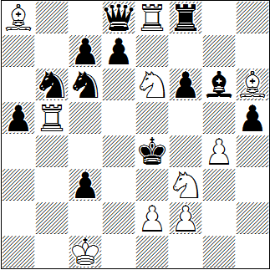
#3 10+12
5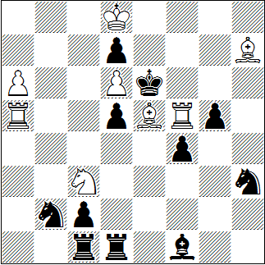
#3 8+11
6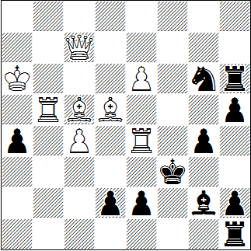
#3 8+11

Dieter Müller, Freie Presse 1975
1. | Seg5+? | Kf4 | 2. | Se4+ | Kxg4!
1. | Sc5? | Kd5 | 2. | Se4+ | Kc4!
1. | Ld2? | Dxe8!
1. | Kc2! | dr. | 2. | Sd2+ | @ | cxd2 | 3. | f3 #
1. | … | hxg4 | 2. | Seg5+ | @ | Kf4+ | 3. | Se4 #
1. | … | Sc4 | 2. | Sc5+ | @ | Kd5+ | 3. | Se4 #

Hugo Knuppert, Thema Danicum 1996
1. | Txd5? | Txd5!
1. | Sxd5? | Txd5!
1. | Sb5? | Lxb5!
1. | Ld4? | Txd4!
1. | a7! | dr. | 2. | a8S | @
1. | ... | Sd3 | 2. | Sxd5 | @
1. | ... | Ld3 | 2. | Txd5 | @
1. | ... | Td3 | 2. | Sb5 | @
1. | ... | Sc4 | 2. | Se4 | @
1. | ... | Td4 | 2. | Lxd4 | @
1. | ... | Te1 | 2. | Sxd5 | @

Claude Goumondy, Freie Presse 1980
1. | Db8! | dr. | 2. | Tb3+ | @
1. | ... | d1~ | 2. | Td4+ | @
1. | ... | Lf1 | 2. | Te3+ | @
1. | ... | Lh3 | 2. | Tf4+ | @
1. | ... | Se5 | 2. | Txe5+ | @
1. | ... | Ta,b,c1 | 2. | Dxh2 | @

@ | 1 | 2 | 3 | 4 | 5 | 6 | 7
3 | 1,5 | 3 | 5
4 | 1 | 1,5 | 2 | 3 | 3,5 | 4 | 5
5 | 1 | 2 | 2,5 | 3 | 4 | 5

