13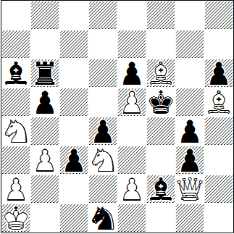
#4 10+12
14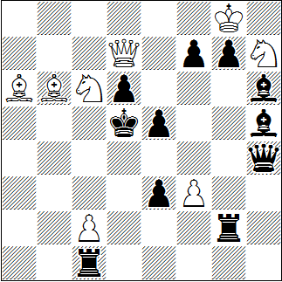
#4 8+11
15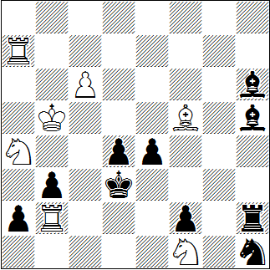
#6 7+10

Siegfried Brüchner, Freie Presse 1978
1. | Sac5? | Lb7!
1. | Dh1! | dr. | 2. | Lg6+ | Kxg6 | 3. | Dh5+ | @
1. | ... | Le3 | 2. | De4+ | Kxe4 | 3. | Lg6+ | @
1. | ... | Tb7 | 2. | Sac5 | g2 | 3. | Dxg2 | @
@ | 1 | 2 | 3
13 | 1,5 | 3 | 5

Peter Hoffmann, Schach-Report 1992, 2. Pr.
1. | Se7+? | Dxe7 | 2. | Db5+ | Ke6 | 3. | Lc8+ | Dd7!
1. | Sb4+? | Dxb4 | 2. | Lb7+ | Kc4 | 3. | Dc6+ | Dc5!
1. | Kh8! | dr. | 2. | Sf6+ | (#3) |  |  | (-)
1. | ... | Lg5 | 2. | Se7+ | Lxe7 | 3. | Db5+ | (2)
1. | ... | Tg4 | 2. | Sb4+ | Txb4 | 3. | Lb7+ | (2)
1. | ... | Dd8+ | 2. | Sxd8 | T~xc2 | 3. | Db5+ | (1)

Ralf Krätschmer, Original für Schach 2015
1. | Le6? | Lf7 | 2. | Lxf7 | Th5+!
1. | Kb4! | Lf8+ | 2. | Te7 | Lxe7+ | 3. | Kb5 | Lg5
4. | Le6 | Lf7 | 5. | Lxf7 | (5)

